**FIJI workshop README**

Texas A&M University at Qatar

By Issac Sujay Anand John Jayachandran, Ph.D. Candidate, Department of Geology and Geophysics, College of Arts and Sciences

**Welcome notes**

So you want to learn ImageJ/Fiji. Why?

You’ve probably, like me, come to the realization that images are a part of your life for the near foreseeable future whether you like it or not. You would have also realized that these images don’t seem to be of the highest quality and while identifying the objects in the images to our human eyes is easy, the computer just doesn’t seem to see it that way. You may have heard whisper of an image analysis software that can do unimaginable things. Automate workflows? why not! Automatically identify the objects in my images? I’ll take that with some sauce please!

In the same whisper, you hear that this software is actually freely available for anyone to use! In a fit of ecstasy, you download this mystical software and are immediately confronted by the blandest GUI you’ve ever seen. Two thoughts immediately spring up; “Is this it?” and “Bland == Steep learning curve”. To the first thought, not entirely. Don’t be fooled by the thin grey characterless strip. There is some serious power underlying it and the more you get into it, the more it will surprise you. Let me put it like this, this is Vin Diesel’s 1993 Honda Civic in the first two Fast and Furious films. Looks pretty basic on the outside until Dominic Toretto flips the boost switch. To the second thought, also not entirely true. There is a bit of a learning curve involved in figuring out all the knobs and controls, but the benefit of being free is that hundreds of people have posted easy to follow tutorials on YouTube, so one can potentially become an expert in no time.

One thing to know about Fiji is that it will present you with a hundred different ways of doing the same task. It’s up to you to choose the best one. This is a daunting task given the overload of options. It’s important to remember Occam’s razor at this juncture, which essentially states that in the presence of several explanations, the simplest one is best. This workshop will give you the mental framework and know-how to make the best choice simply by choosing the most fundamental options available.

Also, in this workshop, I will teach you how to use ImageJ/Fiji based on 2 years of freely playing around with it. By the end of the workshop you will be smashing out high level processing, dealing in different types of segmentation algorithms including machine learning (and deep learning if the image type is right), doling out deep analysis, and developing automated and reproducible batch workflows using the ImageJ programming language. This workshop will not cover every single thing about Fiji but what it will do is provide you with a very solid framework, and some resources, which you can use to build your capability in this software. My hope is that you will develop to the point where you can teach others as well.

And by the way, if you’re confused as to whether ImageJ and Fiji are the same thing, don’ worry, Fiji is basically ImageJ on steroids. In fact, the full form of Fiji is ‘Fiji Is Just ImageJ’. This is what is known as a recursive acronym as it references itself.

This document covers step-by-step the installation procedures for Fiji and the required libraries in preparation for the workshop. I have also included some excellent resources that I found very helpful during my learning curve.

**Download and installation**

Installation for Fiji is straightforward. Simply go to the link below and choose the appropriate link for your OS.

<https://imagej.net/software/fiji/downloads>

**IMPORTANT:** The website does include a warning to install it in your user space rather than in ‘Program files’ as apparently the latter prevents Fiji from getting updated. So try to install it into, for example, C:\Users\[your name]\ImageJ2.app.

Once Fiji is downloaded, it can simply be run by clicking on the ‘ImageJ-win64.exe’ file. Quite simple really.

**Installing the required libraries**

Fiji is quite powerful by itself as the developers have geared it to be ready to go for most biological applications. However, there are several libraries available that boost the abilities of FIJI and in several cases, are quite simple to learn and use. Since these libraries do not come packaged into FIJI, we need to install them within the app. This is also a maddeningly easy task.

**Step 1:** Once you’ve opened Fiji, you should see the following GUI.

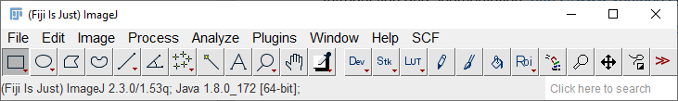

**Step 2:** Click on the Help tab and choose ‘Update…’

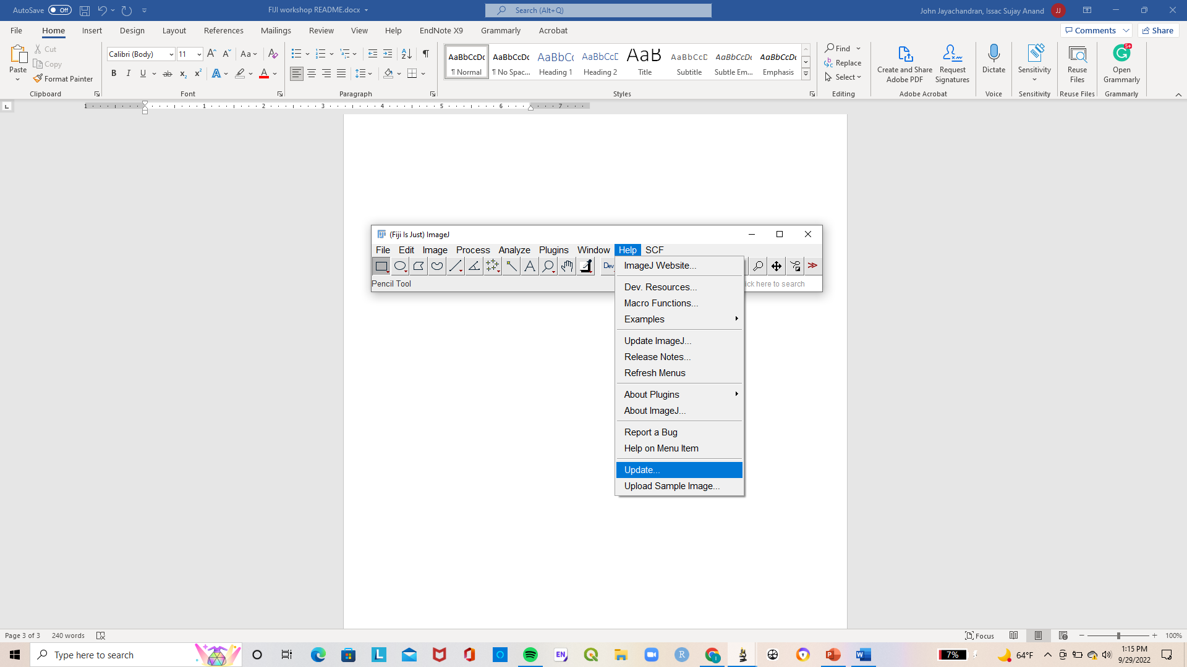

**Step 3:** On the ImageJ Updater window, select the ‘Manage update sites’ option

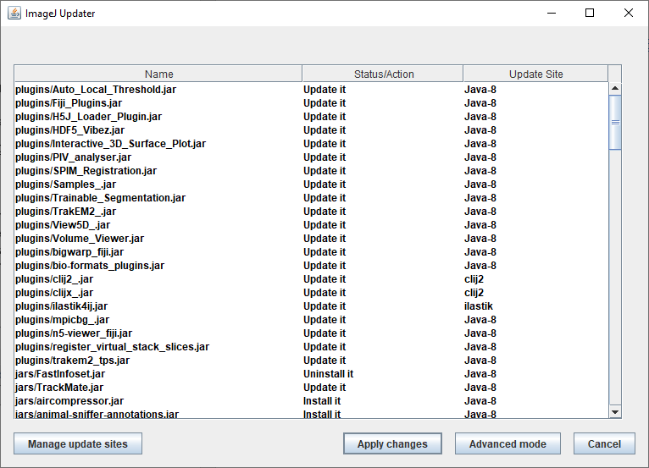

**Step 4:** You should see the following window.

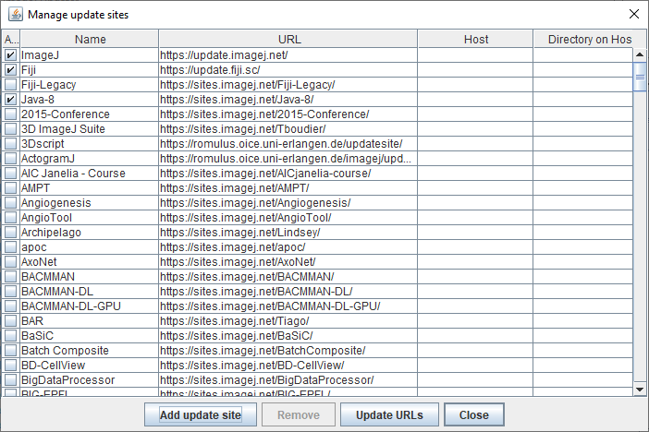

**Check the boxes for the following libraries:**

* BIG-EPFL
* Biomedgroup
* BioVoxxel
* BoneJ
* Clij
* Clij2
* CMP-BIA
* CSBDeep
* DeepImageJ
* EMTool
* IJ-plugins
* IJPB-plugins
* ImageScience
* SCF MPI CBG – Max Plank Institute Cellular Biology Group

**Optional**

* IMCF Uni Basel – It gives a separate GUI for quick analysis, quite interesting but also quite annoying as you’re essentially dealing with the FIJI GUI and the IMCF GUI. But it essentially makes the work much quicker as the options for pre-processing, segmentation, and post-processing are packaged well. Worth a play for quick and dirty processing and analyses.

**Step 5:** Once you’ve done checking the boxes, simply choose the ‘Close’ option, **DO NOT click on ‘Add update site’ or ‘Update URLs’**. This seems a little counterintuitive, but it is what it is.

**Step 6:** You should see the ImageJ Updated window looks populated with all the libraries we have chosen. Choose the ‘Apply changes’ option. This will install the libraries into Fiji once and for all.



**Step 7:** Fiji will install the libraries and it will request you to restart it. Simply close and open Fiji again.

With that you are now ready for the workshop!

Looking forward to seeing you all!

**Resources**

**ImageJ forum:** [www.image.sc](http://www.image.sc)

**Collection of ImageJ/Fiji slides, lectures, and videos from the creators**

<https://imagej.net/events/presentations>

**Dr. Ellen Arena FIJI walkthroughs (University of Wisconsin-Madison)**

Introduction and segmentation: <https://www.youtube.com/watch?v=CZExS_mkGsQ>

Scripting: <https://www.youtube.com/watch?v=agejuH8ebMc>

**NEUBIAS webinars**

Scripting: <https://www.youtube.com/watch?v=o8tfkdcd3DA>

**DeepImageJ:**

Tutorial video: <https://www.youtube.com/watch?v=0vTbsO8Vnuo>

Official website: <https://deepimagej.github.io/deepimagej/>

**Harvard Center for Biological Imaging:**

<https://www.youtube.com/channel/UCvUiCTc-XEaM-QlVqBuL7ug>

**About me**

I am a final year Ph.D. candidate at the department of Geology and Geophysics at the College Station campus, although I have been doing my research at the Qatar campus since June 2021. I am deeply interested in the intersection between geological images, artificial intelligence, and computer vision. I started learning Fiji when the lockdown hit, as a way to work on projects when I had no access to labs. As the lockdown dragged on, my research eventually transitioned to a completely image-based AI domain. I am also working with five undergraduate student researchers from TAMUQ to develop a ML/DL workflow for automatically identifying and classifying rock components from thin section images of carbonate rocks. If you are interested in imaging, computer vision, ML/DL, and data science, or if you’re facing issues with your image processing and analysis pipelines, please do stop by Lab 006 (next door to the UPS office) and you will always find me there ready for a chat.